ITCS454 Special Topics in Database Systems
Final Project: Knowledge-Based Decision Support Systems
Meridian: OCEAN Executive Decision Support System
Decision Maker Personality Assessment and 9-Box Talent Review for a Banking Technology Company
Part 1: Business and Data Understanding
Name | Student ID
Mr. Punnawit Kanogpornwanich | 6688042
Mr. Bhumipat Pengpaiboon | 6688077
Mr. Napas Siripaskrittakul | 6688108

Faculty of Information and Communication Technology, Mahidol University
Instructor: Assoc. Prof. Dr. Jarernsri Mitrpanont
Submitted 12 November 2026
Source code: https://github.com/Punnaw1t/mbti-banking-app
Table of Contents
1. Project Overview
1.1 The System
1.2 Source Code Repository
2. Motivation and Problem Statement
2.1 Motivation
2.2 Problem Statement
2.3 From Business Problem to Analytical Problem
3. Objectives, Decision Makers and Success Metrics
3.1 Objectives
3.2 Decision Makers and Actors
3.3 Use Case Diagram
3.4 Decision Style Rules: from Personality to Decision Maker Style
3.5 Key Performance Indicators
4. Data Profile and Quality
4.1 Dataset Overview
4.2 Data Dictionary
4.3 Entity-Relationship Diagram
4.4 Data Quality Assessment
4.5 Data Cleaning and Preprocessing Workflow
4.6 Data Analysis
5. Knowledge and Logical Modeling
6. Interface Design and Implementation
References

The table of contents follows the structure of the whole project. Chapters 5 and 6 are completed in Part 2 (due 19 November) and Part 3 (due 26 November).

1. Project Overview

1.1 The System
Meridian is a decision support system for a banking technology company. Every employee takes the 50-item IPIP Big Five (OCEAN) test. The system scores five traits (Openness, Conscientiousness, Extraversion, Agreeableness and Neuroticism), converts them to percentiles against 592,204 benchmark respondents and shows them on a five-sided radar chart. It then assigns one of six decision profiles and computes a Leadership Index that flags executive-track candidates.
HR staff and executives see these results next to a 9-Box Talent Grid built from HR records. The grid combines a performance axis (last year's rating, KPI attainment and awards) with a potential axis (a promotion model). Together they answer the decision this project supports: who should be developed, placed or shortlisted for leadership roles, and which department needs action first.
This project builds on Project 1, which measured employees with MBTI. Part 1 replaces MBTI with OCEAN because OCEAN scores each trait on a continuous scale that can be compared with a population benchmark, while MBTI forces each person into one of 16 types and has no link to performance data.

1.2 Source Code Repository
All code, data and build scripts referenced in this report are in the project's GitHub repository. The OCEAN version is on the branch feature-implement-OCEAN. The master branch still holds the MBTI version from Project 1.
Table 1. Repository references
Item | Location | Purpose
Repository | https://github.com/Punnaw1t/mbti-banking-app | Next.js 14 and TypeScript web application, public
Branch used in this report | feature-implement-OCEAN | OCEAN version, commit e2d4d92
Data build script | data/build_ocean_dataset.py | Cleans and joins the three Kaggle datasets, fixed seed 42
Data method notes | data/README.md | Method, assumptions and column list of the output data
Employee dataset | data/employees_ocean_hr.csv | 17,414 employees × 36 columns, the main analysis file
Percentile norms | data/ocean_norms.csv | Raw score to percentile lookup, 41 rows × 6 columns
Scoring and rules | lib/ocean.ts | Trait scoring, percentiles, profiles and Leadership Index
Question bank | lib/questions.ts | The 50 IPIP items with reverse-key flags
Norms used by the app | lib/oceanNorms.ts | Generated from the same data as ocean_norms.csv

The raw Kaggle files are not committed because of their size (the IPIP file alone has over one million rows). To rebuild the output files, download the three datasets listed in Table 11 and run:
python data/build_ocean_dataset.py --raw <folder with big5/ hrana/ empperf/> --repo .
The script needs pandas, NumPy and scikit-learn. It writes data/employees_ocean_hr.csv, data/ocean_norms.csv and lib/oceanNorms.ts. On 10 November 2026 the three datasets were downloaded again from Kaggle and the script was rerun: all three output files were byte-for-byte identical to the committed ones. Every raw-data figure in this report was recomputed from those downloads.

2. Motivation and Problem Statement

2.1 Motivation
A bank depends on the decisions of its technology leaders. A wrong call during an incident, a platform change or a digital banking launch can reach customers and regulators, so who holds these roles matters. Past performance alone does not answer that question, because it shows how well someone did in the current role and not how they decide or how far they can grow.
The HR data shows the gap:
- In hr-ana train.csv (54,808 employees), only 8.5% were promoted. Even among employees with the top rating of 5, only 16.4% were promoted, so a high rating does not settle who moves up.
- In the employee file, 2,044 rated employees (12.7%) sit in the Enigma cell of the 9-Box Grid, with high potential but low performance. Their talent is not turning into results.
- Only 27.7% of Retail Banking staff met more than 80% of their KPIs, the lowest of the six departments.
Personality adds what these records lack. The Big Five traits have a multiple correlation of 0.48 with leadership (Judge et al., 2002), and Conscientiousness is the strongest trait predictor of job performance at 0.19 (Sackett et al., 2022).

2.2 Problem Statement
HR and executives at the bank have no single, comparable view of how a leader decides, how that leader performs and how far they could grow. Succession decisions are therefore hard to justify, and a mismatch between a leader's decision style and the role is found late.

2.3 From Business Problem to Analytical Problem
Table 2. Business questions translated into measurable analytical problems
Business question | Analytical problem | Measured by | Decision maker
How does each leader make decisions, compared with others? | Score the 50-item test into five traits, convert to percentiles and classify a decision profile | KPI 1, 2, 7 | Employee, EM, HR
Who should enter the succession pool? | Rank employees by Leadership Index and place them on a performance by potential grid | KPI 3, 5, 6 | HR, CEO
Which department needs action first? | Compare department rates against the alert thresholds | KPI 2, 3, 4, 6 | HR, CEO, CTO, EM

The personality scores in the employee file are a synthetic link (section 4.1), so the system demonstrates this decision process and does not measure an effect of personality on these employees.

3. Objectives, Decision Makers and Success Metrics

3.1 Objectives
- Give every leader a valid, comparable OCEAN profile instead of a forced four-letter type, with at least 95% of employees holding a completed result within 30 days of launch (KPI 7).
- Show each department how its decision profiles are spread, so that no single profile exceeds 35% of any department (KPI 2).
- Find executive-track leaders and check them against their real performance and potential before placement, with executive fit at 10% or more in every department and every shortlisted Star reviewed by HR (KPI 3, KPI 6).
- Bring the Low performance band to 45% or less of rated employees in every department, starting with Retail Banking (KPI 4).

3.2 Decision Makers and Actors
Every actor in the system is a job role, not an organizational unit. Retail Banking, Corporate Banking, Customer Service, Finance and Accounting, IT Support and Human Resources are departments: they describe where a person works and limit which results a role may see, but they are never actors. Each user therefore has two separate attributes, a role (what they do in the system) and a department (where they work).
Employees use Flow 1 to take the test and read their own result. The four reviewer roles use Flow 2 to review results for the business units in their scope. Login routes a user to Flow 2 when their role is HR Staff, Engineering Manager, CTO or CEO, and to Flow 1 when it is Employee.
Table 3. Actors (job roles) and the decisions they make
Actor (job role) | Decisions supported | Business units in scope
Employee | Reads their own profile and suggestion, and decides on personal development | Own result only
HR Staff | Shortlists executive-fit Stars, plans coaching for Enigmas and Dilemmas, follows up on incomplete tests | All six business units
Engineering Manager | Balances decision styles within a team and assigns stretch work | Retail Banking, Corporate Banking, Customer Service, Finance and Accounting
CTO (Chief Technology Officer) | Chooses technology leads for incident command, platform and architecture roles | IT Support
CEO (Chief Executive Officer) | Approves the leadership succession shortlist and decides which business unit gets development budget first | All six business units

In the Project 1 prototype the role was stored in the department field (for example, "Engineering Manager" was listed as a department). This report separates the two in the data model (ROLE and ROLE_SCOPE in section 4.3), and the prototype will follow in Part 3.

3.3 Use Case Diagram
Figure 1 shows the five actors. The four reviewer roles share six oversight use cases through UML generalization from an abstract Reviewer actor, so each role is still drawn and named on its own. Only HR Staff and the CEO can open the 9-Box Talent Grid, and only the CEO approves the succession shortlist. Table 4 lists the same access as a matrix.
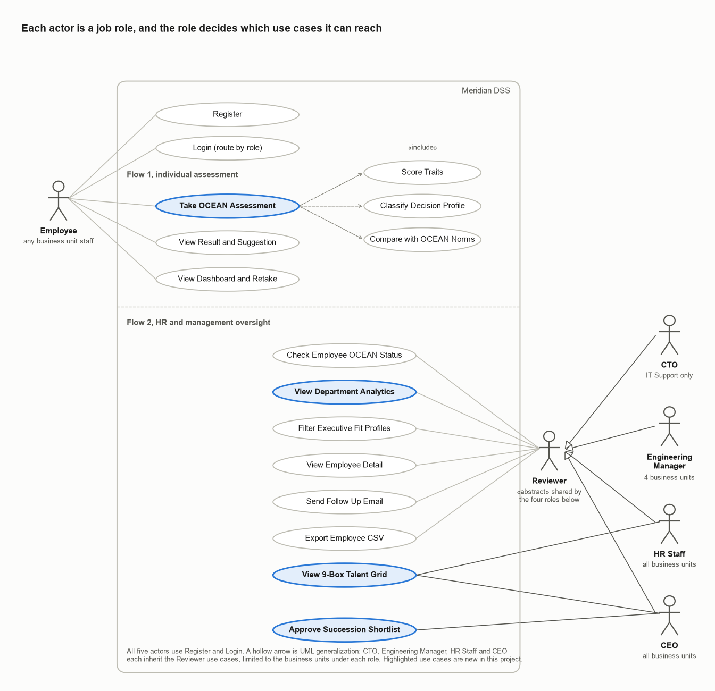
Figure 1. Use case diagram with one actor per job role
Table 4. Actor and use case matrix
Use case | Employee | HR Staff | Eng. Manager | CTO | CEO
Register, Login | ✓ | ✓ | ✓ | ✓ | ✓
Take OCEAN Assessment (includes Score Traits, Classify Decision Profile, Compare with OCEAN Norms) | ✓
View Result and Suggestion, View Dashboard and Retake | ✓
Check Employee OCEAN Status |  | ✓ | ✓ | ✓ | ✓
View Department Analytics (charts) |  | ✓ | ✓ | ✓ | ✓
Filter Executive Fit Profiles, View Employee Detail |  | ✓ | ✓ | ✓ | ✓
Send Follow Up Email, Export Employee CSV |  | ✓ | ✓ | ✓ | ✓
View 9-Box Talent Grid |  | ✓ |  |  | ✓
Approve Succession Shortlist |  |  |  |  | ✓

3.4 Decision Style Rules: from Personality to Decision Maker Style
These rules turn an employee's five trait scores into a decision-maker style. They are implemented in lib/ocean.ts (getProfile, leadershipIndex) and give the same result as the Python build script for all 17,414 employees.

Step 1. Trait band
Table 5. Trait band rules
Rule | IF | THEN
B1 | Trait percentile < 30 | Trait band = Low
B2 | 30 ≤ trait percentile < 70 | Trait band = Moderate
B3 | Trait percentile ≥ 70 | Trait band = High

Step 2. Decision profile (decision-maker style)
Neuroticism is turned into emotional stability first, S = 100 − N percentile, so that a higher score always means a stronger leadership trait. The strongest of E, C, S, O and A then decides the profile.
Table 6. Decision profile rules
Rule | IF | THEN
R1 | Highest of E, C, S, O, A percentiles is ≥ 60 and it is E | Profile = The Mobiliser
R2 | Highest is ≥ 60 and it is C | Profile = The Steward
R3 | Highest is ≥ 60 and it is S (100 − N) | Profile = The Steady Hand
R4 | Highest is ≥ 60 and it is O | Profile = The Visionary
R5 | Highest is ≥ 60 and it is A | Profile = The Consensus Builder
R6 | No trait reaches the 60th percentile | Profile = The Balanced Generalist
R7 | Two traits tie for highest | The earlier trait in the order E, C, S, O, A wins

Table 7. Decision profiles and decision-maker styles
Profile | Strongest trait | Decision-maker style | Where it fits in a bank
The Mobiliser | Extraversion | Decisive, people-led driver who rallies teams quickly | Growth mandates, client-facing divisions, change programmes
The Steward | Conscientiousness | Disciplined, process-first executor who decides on evidence and controls | Risk, compliance, audit and operations leadership
The Steady Hand | Emotional stability (low N) | Composed decider who stays calm under pressure | Incident command, crisis response, treasury
The Visionary | Openness | Long-horizon systems thinker open to new options | Strategy, product innovation, enterprise technology
The Consensus Builder | Agreeableness | Trust-building, collaborative decider who seeks agreement | Customer experience, talent, cross-functional leadership
The Balanced Generalist | None at the 60th percentile | Adaptable, situational decider with no dominant style | Rotational and generalist roles

Step 3. Leadership Index and executive fit
The Leadership Index weights each percentile by that trait's correlation with leadership in Judge et al. (2002): E 0.31, C 0.28, N −0.24, O 0.24 and A 0.08. Dividing by the sum of the weights (1.15) keeps the index on a 0 to 100 scale.
LI = (0.31 E + 0.28 C + 0.24 (100 − N) + 0.24 O + 0.08 A) ÷ 1.15
Table 8. Executive fit rule
Rule | IF | THEN
L1 | Leadership Index ≥ 70 | Executive fit = Yes, flag for the executive track
L2 | Leadership Index < 70 | Executive fit = No

Worked example (employee 3, Corporate Banking). Percentiles are O 63, C 67, E 31, A 21 and N 84, so S = 16. The highest of E, C, S, O, A is C at 67, which is at least 60, so rule R2 gives The Steward. The Leadership Index is (0.31 × 31 + 0.28 × 67 + 0.24 × 16 + 0.24 × 63 + 0.08 × 21) ÷ 1.15 = 42.6, below 70, so executive fit is No.
Part 2 extends these rules into the full decision table and decision tree, together with the validity, scoring and 9-Box rule sets.

3.5 Key Performance Indicators
The system tracks seven KPIs: three from the OCEAN assessment, three from the 9-Box Grid and one for adoption. Each baseline comes from the cleaned IPIP benchmark (592,204 respondents) or the employee file (17,414 employees).
Table 9. KPI definitions, baselines and alert rules
KPI | Calculation | Baseline | Alert rule | Owner
KPI 1 Trait Percentile | Percentile of each raw trait score in OCEAN_NORM | Median raw O 40, C 34, E 29, A 39, N 31 | Yellow when a department's mean percentile on a trait is outside 40 to 60 | Employee, EM, HR
KPI 2 Decision Profile Distribution | Results with profile p ÷ results × 100 | IPIP: C 18.2%, S 17.4%, E 17.4%, O 17.3%, A 16.1%, B 13.5% | Yellow when one profile is over 35% of a team, Red over 50% | CEO, HR, CTO
KPI 3 Executive Fit Rate | Results with Leadership Index ≥ 70 ÷ results × 100 | IPIP 12.3%, employee file 14.5% (2,518) | Red when a department falls below 10% | HR, CEO
KPI 4 Performance Index | Percentile of weighted rating, KPI flag and award (rated employees) | High 33.0%, Medium 23.5%, Low 43.5% of 16,051 | Yellow when Low band > 45% of a department, Red > 50% | EM, HR
KPI 5 Potential Index | Percentile of the promotion model score | Thirds by design, model AUC 0.714 | Green when High band ≥ 33.3%, Yellow below, Red below 25% | HR, CEO
KPI 6 9-Box Talent Pipeline | Rated employees per cell ÷ 16,051 × 100 | Star 11.5% (1,844). Star and executive fit: 357 | Yellow when Stars are under 10% of a department | HR, CEO
KPI 7 Assessment Completion Rate | Employees with a result ÷ employees × 100 | Prototype seed 88.9% (8 of 9) | Yellow below 90%, Red below 70% | HR

Table 10. KPI targets
KPI | Target | Baseline
KPI 1 | Every completed result has all five percentiles | Met in the employee file
KPI 2 | No profile over 35% of any department | Highest 27.5%, Finance and Accounting
KPI 3 | 10% or more in every department | Lowest 11.4%, IT Support
KPI 4 | Low band at 45% or less in every department | Three departments above 45%
KPI 5 | High band at 30% or more in every department | Lowest 29.8%, Customer Service
KPI 6 | Stars at 10% or more of rated employees in every department, all 357 shortlisted employees reviewed | Lowest 8.4%, Retail Banking
KPI 7 | 95% or more within 30 days of launch | Prototype seed 88.9%

At baseline, KPI 4 is Yellow for Retail Banking (49.8% Low), IT Support (48.8%) and Corporate Banking (47.9%). KPI 6 is Yellow for Retail Banking, where Stars are 8.4% of rated employees. The thresholds and targets are proposed by this report and can be tuned by HR. Performance and potential bands are relative to current employees, so progress on KPI 4 to KPI 6 should be measured against cut-offs frozen at this baseline.

4. Data Profile and Quality
The system draws on three public Kaggle datasets. After cleaning, 592,204 of the 1,015,341 IPIP responses (58.3%) form the OCEAN norms, and 17,414 employees from the two HR datasets carry the 9-Box axes.

4.1 Dataset Overview
Table 11. Dataset overview
Property | IPIP Big Five Personality Test | hr-ana | Employee's Performance for HR Analytics
Source | Open Psychometrics online test, Kaggle (Tunguz) | Kaggle (arashnic) | Kaggle (sanjanchaudhari)
Files | data-final.csv, codebook.txt | train.csv, test.csv | Uncleaned_employees_final_dataset (1).csv
Granularity | One row per test submission | One row per employee | One row per employee
Data type | Structured, tab-separated | Structured CSV | Structured CSV
Volume | 1,015,341 rows × 110 columns | train.csv 54,808 rows × 13 columns, test.csv 23,490 rows × 12 columns | 17,417 rows × 13 columns
Period | 3 March 2016 to 8 November 2018 | One snapshot, no dates | One snapshot, no dates
Used for | OCEAN scores and percentile norms | Potential model (train), employee records (test) | Employee list and KPI flag

How the datasets fit together. The two HR datasets describe one population. All 17,414 distinct employees in the performance file are in test.csv and every shared column agrees, so the performance file is test.csv with a KPI column added. train.csv is a separate group with no overlap, and it is the only file with is_promoted, so promotion is modelled rather than joined.
The personality data comes from different people and shares no key with the HR data. The build script therefore pairs each employee with a real, anonymous IPIP respondent from the same assumed department profile, chosen so that trait and performance correlations match published research (Sackett et al., 2022). The output, employees_ocean_hr.csv, has 17,414 rows × 36 columns. This synthetic link is suitable for building and demonstrating the DSS, but:
- Trait and performance correlations were set on purpose, so finding them again proves nothing.
- Department differences in personality are assumptions, not findings.
- Personality was matched only on department and performance, so any pattern with age, gender, region or education is meaningless.
- The file must not be used for real decisions about real people.

4.2 Data Dictionary
The data dictionary has one table for each source dataset and one for the integrated file the system uses. Field names are written exactly as in the source files.

Dataset 1. IPIP Big Five Personality Test
The file has 110 columns. The 50 item answers are used for scoring. The time, IP and country fields are used only for cleaning and profiling.
Table 12. Data dictionary, Dataset 1: IPIP data-final.csv (110 columns)
Field | Data type | Description | Range in raw file | Example (row 1)
EXT1 to EXT10 | Integer (read as decimal because of blank rows) | Extraversion item answers | 0 to 5, 0 = skipped, blank in 1,783 rows | 4
EST1 to EST10 | Integer | Neuroticism item answers (labelled Emotional Stability in the file, but high means less stable) | 0 to 5, 0 = skipped | 1
AGR1 to AGR10 | Integer | Agreeableness item answers | 0 to 5, 0 = skipped | 2
CSN1 to CSN10 | Integer | Conscientiousness item answers | 0 to 5, 0 = skipped | 3
OPN1 to OPN10 | Integer | Openness item answers | 0 to 5, 0 = skipped | 5
EXT1_E to OPN10_E | Integer | Milliseconds spent on each item | −79,175,662 to 2,147,483,647 (invalid values, see 4.4) | 9419
dateload | Datetime (text) | Time the survey started | 2016-03-03 02:01:01 to 2018-11-08 12:08:45 | 2016-03-03 02:01:01
testelapse | Integer, nullable | Seconds spent on the question page | 1 to 11,892,718, blank in 1,783 rows | 234
IPC | Integer | Number of records from the same IP address | 1 to 725 | 1
country | String (2), nullable | Country code from technical information | ISO 2-letter, NONE, or blank (77 rows) | GB
screenw, screenh | Integer, nullable | Screen width and height in pixels | 0 to 13,660 and 0 to 8,802 | 768, 1024
introelapse, endelapse | Integer | Seconds on the intro page and the end page | 0 to 29,443,071 and 1 to 1,493,327,022 | 9, 6
lat_appx_lots_of_err, long_appx_lots_of_err | Decimal (text) | Approximate latitude and longitude, with large error | −90 to 72 and −175.3 to 178.4 | 51.5448, 0.1991

Dataset 2. hr-ana (train.csv and test.csv)
Both files have one row per employee and share 12 fields. train.csv has one more, is_promoted. Neither file has a KPI column; it comes from Dataset 3. Ranges are measured in each raw file, and the example is employee 3 from test.csv.
Table 13. Data dictionary, Dataset 2: hr-ana train.csv (13 columns) and test.csv (12 columns)
Field | Data type | Description | Range in train.csv | Range in test.csv | Example
employee_id | Integer | Unique employee identifier (PK). No ID appears in both files | 1 to 78,298, 54,808 unique | 3 to 78,295, 23,490 unique | 3
department | String | Source department | 9 values: Analytics, Finance, HR, Legal, Operations, Procurement, R&D, Sales & Marketing, Technology | Same 9 | Procurement
region | String | Anonymized work region | region_1 to region_34 | Same | region_22
education | String, nullable | Highest education | Bachelor's, Below Secondary, Master's & above, blank 2,409 | Same, blank 1,034 | Master's & above
gender | Char (1) | Gender | f, m | f, m | f
recruitment_channel | String | How the employee was hired | other, referred, sourcing | Same | other
no_of_trainings | Integer | Trainings attended last year | 1 to 10 | 1 to 9 | 1
age | Integer | Age in years | 20 to 60 | 20 to 60 | 38
previous_year_rating | Decimal, nullable | Last year's performance rating, blank in the first year | 1.0 to 5.0, blank 4,124 | 1.0 to 5.0, blank 1,812 | 5.0
length_of_service | Integer | Years of service | 1 to 37 | 1 to 34 | 4
awards_won? | Boolean (0/1) | 1 if an award was won last year. Renamed awards_won | 0, 1 | 0, 1 | 0
avg_training_score | Integer | Average score of the trainings | 39 to 99 | 39 to 99 | 67
is_promoted | Boolean (0/1) | 1 if promoted. Target of the potential model | 0, 1 (8.5% are 1) | Not in file | –

Dataset 3. Employee's Performance for HR Analytics
This file has 13 columns: the 12 fields of test.csv, with two names and two labels spelled differently, plus the KPI flag. All 17,414 distinct IDs are in test.csv and none are in train.csv. Only employee_id and the KPI flag are used. The other fields come from test.csv, because one of the file's 3 surplus rows conflicts with test.csv (section 4.4).
Table 14. Data dictionary, Dataset 3: Uncleaned_employees_final_dataset (1).csv (13 columns)
Field | Data type | Description | Range in raw file | Example | Used for
employee_id | Integer | Employee identifier, join key to test.csv | 3 to 78,295, 17,414 distinct in 17,417 rows | 3 | Join key
KPIs_met_more_than_80 | Boolean (0/1) | 1 if the employee met more than 80% of their KPIs. Only in this file | 0, 1 | 1 | Performance axis
education | String, nullable | Highest education, spelled differently from Dataset 2 | Bachelors, Below Secondary, Masters & above, blank 771 | Masters & above | Cross-check
awards_won | Boolean (0/1) | Same as awards_won? in Dataset 2, without the question mark | 0, 1 | 0 | Cross-check
previous_year_rating | Decimal, nullable | Same as Dataset 2 | 1.0 to 5.0, blank 1,363 (all with 1 year of service) | 5.0 | Cross-check
department, region, gender, recruitment_channel, no_of_trainings, age, length_of_service, avg_training_score | Mixed | Same names and meaning as Dataset 2 | Same as test.csv | Procurement, region_22, … | Cross-check

Integrated file: employees_ocean_hr.csv
The build script joins the three datasets into one row per employee. Table 15 lists the fields the system uses, with the dataset each one comes from. Derived fields are computed by the build script and the rules in section 3.4.
Table 15. Data dictionary, integrated employees_ocean_hr.csv (22 of 36 columns)
Field | Data type | Description | Valid range / constraint | Example | Source
employee_id | Integer | Unique employee identifier from the source data | PK, 17,414 unique, not null | 3 | Dataset 2 (test.csv)
department | String (40) | Meridian department, mapped from source_department | 6 values | Corporate Banking | Derived
source_department | String (40) | Department name in the source file, kept for audit | 9 values | Procurement | Dataset 2 (test.csv)
region | String (10) | Anonymized work region | 34 values | region_22 | Dataset 2 (test.csv)
education | String (20) | Highest education, standardized | Bachelor's, Master's & above, Below Secondary, Unknown | Master's & above | Dataset 2 (test.csv)
gender | Char (1) | Gender | m, f | f | Dataset 2 (test.csv)
recruitment_channel | String (10) | How the employee was hired | other, sourcing, referred | other | Dataset 2 (test.csv)
age | Integer | Age in years | 20 to 60 | 38 | Dataset 2 (test.csv)
length_of_service | Integer | Years of service | 1 to 34, at most age − 18 | 4 | Dataset 2 (test.csv)
no_of_trainings | Integer | Trainings attended last year | 1 to 9 | 1 | Dataset 2 (test.csv)
avg_training_score | Integer | Average score of the trainings | 39 to 99 | 67 | Dataset 2 (test.csv)
previous_year_rating | Decimal, nullable | Last year's performance rating | 1.0 to 5.0, null for 1,363 first-year employees | 5.0 | Dataset 2 (test.csv)
kpis_met_more_than_80 | Boolean (0/1) | 1 if more than 80% of KPIs were met | 0, 1 | 1 | Dataset 3
awards_won | Boolean (0/1) | 1 if an award was won last year | 0, 1 | 0 | Dataset 2 (test.csv)
O_raw … N_raw | Integer × 5 | Raw trait totals after reverse keying | 10 to 50 | 42, 37, 24, 32, 40 | Dataset 1 (linked)
O_pct … N_pct | Integer × 5 | Percentile of each raw score in OCEAN_NORM | 0 to 100 | 63, 67, 31, 21, 84 | Derived
decision_profile | String (30) | Decision profile from the strongest trait | 6 profiles | The Steward | Derived
leadership_index | Decimal (4,1) | Weighted mean of the five percentiles (Judge et al., 2002) | 0 to 100 | 42.6 | Derived
executive_fit | String (3) | Yes when leadership_index ≥ 70 | Yes, No | No | Derived
performance_index | Decimal (4,1) | Percentile of the weighted performance score | 0 to 100, null if not rated | 92.2 | Derived
potential_index | Decimal (4,1) | Percentile of the promotion model score | 0 to 100 | 75.5 | Derived
nine_box, nine_box_label | Integer, String | 9-Box cell and its name | 1 to 9 or Not rated | 3, Star | Derived

4.3 Entity-Relationship Diagram
The system has thirteen entities. ROLE and ROLE_SCOPE are new: they separate a user's job role from their department, so departments are only used for scope and grouping. The prototype stores USER (with the result embedded) and EMAIL_LOG in the browser, while QUESTION, ANSWER, OCEAN_NORM and DECISION_PROFILE live in code. HR_RECORD, TALENT_REVIEW and NINE_BOX_CELL hold the HR data behind the 9-Box Grid. TEST_RESULT stores only the five raw scores. Percentiles, the decision profile and the Leadership Index are derived at run time, so a result never goes stale when the norms or rules change.
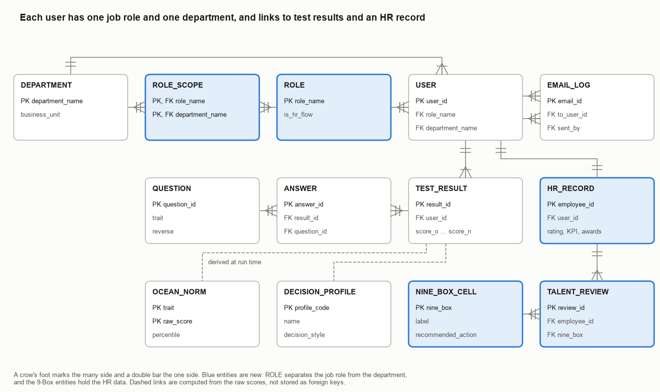
Figure 2. Entity-Relationship Diagram (crow's foot notation)
Table 16. Entities
Entity | Purpose | Key attributes
ROLE | The 5 job roles (actors) and the flow each routes to | role_name (PK), is_hr_flow
ROLE_SCOPE | Which business units a reviewer role may view | role_name (PK, FK), department_name (PK, FK)
DEPARTMENT | The 6 business units where people work | department_name (PK), business_unit
USER | Every account in Flow 1 and Flow 2 | user_id (PK), name, email, role_name (FK), department_name (FK)
QUESTION | The fixed IPIP-50 question bank | question_id (PK), trait, prompt, reverse
TEST_RESULT | One completed assessment | result_id (PK), user_id (FK), score_o … score_n, completed_at
ANSWER | Each answer in one attempt | answer_id (PK), result_id (FK), question_id (FK), answer_value
OCEAN_NORM | Percentile of each raw trait score | trait (PK), raw_score (PK), percentile
DECISION_PROFILE | Strongest trait to decision profile | profile_code (PK), name, decision_style, description
EMAIL_LOG | Follow-up emails sent from Flow 2 | email_id (PK), to_user_id (FK), sent_by (FK), subject, sent_at
HR_RECORD | HR attributes of an employee | employee_id (PK), user_id (FK), rating, KPI flag, awards, training
TALENT_REVIEW | One 9-Box placement | review_id (PK), employee_id (FK), performance_index, potential_index, nine_box (FK)
NINE_BOX_CELL | The 9 cells and their actions | nine_box (PK), label, recommended_action

4.4 Data Quality Assessment

Completeness
Table 17. Missing values and decisions
Dataset and column | Missing | % | Decision and justification
IPIP, all items and times blank | 1,783 rows | 0.18% | Drop, nothing to score
IPIP, any item coded 0 (skipped) | 139,124 rows | 13.70% | Drop, a trait cannot be scored with a missing item
IPIP, screenw, screenh, introelapse | 2,066 rows | 0.20% | Keep, not used in scoring
IPIP, country blank or NONE | 13,805 rows | 1.36% | Keep, recode to Unknown
train.csv, education | 2,409 of 54,808 | 4.40% | Keep as Unknown in the potential model
train.csv, previous_year_rating | 4,124 of 54,808 | 7.52% | Keep, rating is not a model input
test.csv, education | 1,034 of 23,490 | 4.40% | Keep as Unknown
test.csv, previous_year_rating | 1,812 of 23,490 | 7.71% | Keep, set to Not rated
Performance file, education | 771 of 17,417 | 4.43% | Keep as Unknown
Performance file, previous_year_rating | 1,363 of 17,417 | 7.83% | Keep. All are first-year employees, so they get Not rated and no 9-Box cell
All other HR columns | 0 | 0% | Keep

Accuracy
Table 18. Range and outlier checks
Check | Finding | Decision
IPIP item answers | All non-blank values are 0 to 5, and 0 means skipped (0.73% of cells) | Rows with 0 dropped
IPIP testelapse | Median 224 s, 1st percentile 91 s, maximum 11,892,718 s (about 138 days). 23,873 rows (2.4%) fall outside 100 to 3,600 s, and 1,783 rows are blank | Keep 100 to 3,600 s only
IPIP item times | 826 negative cells and 13 cells at 2,147,483,647, the 32-bit integer limit | Keep rows, times are not used in scoring
IPIP screen size | 2,724 rows with width and height of 0 | Keep, not used
HR age and service | Age 20 to 60, service 1 to 34 years, service never exceeds age minus 18 | No action
HR scores and flags | Training score 39 to 99, rating 1 to 5, KPI and award flags only 0 or 1 | No action
HR outliers (1.5 × IQR) | age: 453 rows (2.6%) above 54. length_of_service: 1,083 rows (6.2%) above 13. avg_training_score: 0. no_of_trainings: IQR is 0 because most attended once, so 3,356 rows (19.3%) are flagged that are not errors | Keep all, values are plausible and inside valid ranges

Consistency
Table 19. Consistency checks
Check | Finding | Decision
IPIP repeated submissions | 318,496 rows (31.4%) share an IP address (IPC > 1) | Keep IPC = 1 only, as the codebook advises
IPIP straight-lining | 4,791 rows (0.5%) have an answer SD under 0.5, which contradicts the reverse-keyed items. 293 of them are left after the earlier steps | Drop
IPIP trait label | The EST prefix is named Emotional Stability, but its positive items measure Neuroticism | Report the trait as N
HR surplus rows | The performance file has 3 more rows than distinct employees: 2 exact duplicates (employee 49584) and 1 that conflicts with test.csv (employee 64573) | Treat test.csv as correct, take only employee_id and the KPI flag from the performance file
HR education labels | Spelled two ways across files (Bachelors and Bachelor's, Masters & above and Master's & above) | Standardize to one spelling
HR first-year ratings | 135 employees with 1 year of service still have a previous-year rating | Keep, flag for HR to check
HR department names | Source departments do not match Meridian's | Map with Table 20, keep source_department for audit

4.5 Data Cleaning and Preprocessing Workflow
All steps run in data/build_ocean_dataset.py, so the cleaning is repeatable. The IPIP data goes through four filters (Figure 3).
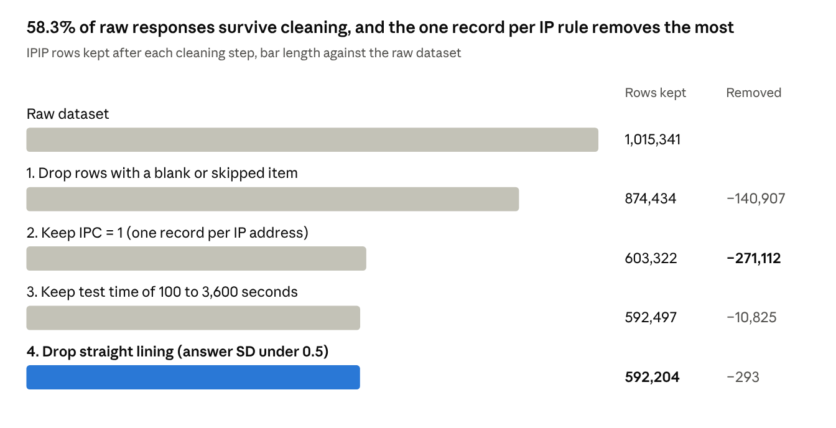
Figure 3. IPIP cleaning steps and rows kept
The HR data goes through seven steps:
- Remove the 3 surplus rows from the performance file (17,417 to 17,414) and keep only employee_id and the KPI flag.
- Join to hr-ana test.csv on employee_id, one to one.
- Standardize education spellings and turn blanks into Unknown.
- Map the 9 source departments to 6 Meridian departments (Table 20).
- Compute the performance index for rated employees and the potential index from a model trained on train.csv.
- Band both axes into thirds and assign the 9-Box cell.
- Link each employee to one cleaned IPIP respondent by statistical matching within the department.
Table 20. Department mapping (grouping)
Source department | Meridian department | Employees
Sales & Marketing | Retail Banking | 5,458
Operations | Customer Service | 3,524
Procurement, Legal | Corporate Banking | 2,572
Technology, R&D | IT Support | 2,531
Finance, Analytics | Finance and Accounting | 2,499
HR | Human Resources | 830

Transformations
Table 21. Data transformations
Transformation | Rule | Why
Reverse keying | 18 negatively worded items are scored as 6 − answer | So a higher score always means more of the trait
Aggregation | Sum of 10 items per trait, giving 10 to 50 | One score per trait
Normalization to percentile | Mid-rank percentile among 592,204 respondents: 100 × (below + 0.5 × at) ÷ 592,204 | Raw scores are not comparable across traits. A raw 30 is the 8th percentile for Openness but the 54th for Extraversion
Peer z-score | Training score standardized within the source department | Training scores differ by department (mean 50.1 to 80.5)
Weighted performance score | 0.5 × (rating − 1) ÷ 4 + 0.4 × KPI flag + 0.1 × award, then percentile | Combines three HR signals into one axis
Grouping into bands | Percentile < 33.3 Low, < 66.7 Medium, else High | Builds the 3 × 3 grid

4.6 Data Analysis

OCEAN benchmark
Cronbach's alpha is 0.80 to 0.90 for every trait, so each 10-item scale is reliable. Openness and Agreeableness score high for most people, while Extraversion is the most spread out trait (Table 22, Figure 4).
Table 22. Descriptive statistics of raw trait scores (n = 592,204)
Trait | Mean | SD | Q1 | Median | Q3 | Cronbach's α
O Openness | 39.4 | 6.2 | 35 | 40 | 44 | 0.80
A Agreeableness | 37.6 | 7.4 | 33 | 39 | 43 | 0.84
C Conscientiousness | 33.4 | 7.4 | 28 | 34 | 39 | 0.82
N Neuroticism | 30.8 | 8.6 | 25 | 31 | 37 | 0.87
E Extraversion | 29.1 | 9.1 | 22 | 29 | 36 | 0.90

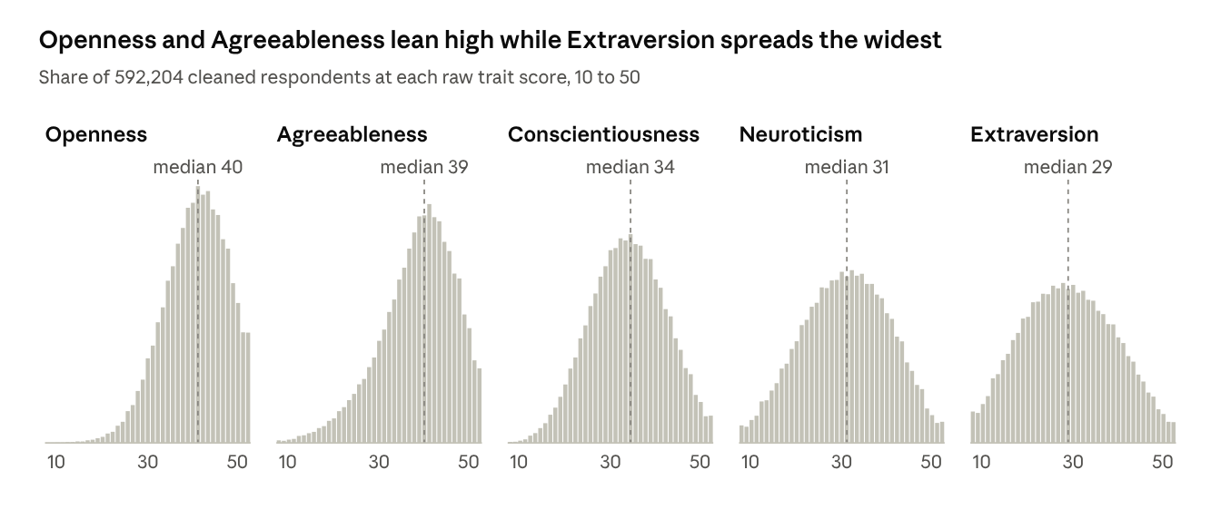
Figure 4. Distribution of raw trait scores
Table 23. Correlation between traits (Pearson, n = 592,204)
 | O | C | E | A | N
O | 1.00 | 0.05 | 0.18 | 0.10 | −0.08
C | 0.05 | 1.00 | 0.07 | 0.14 | −0.24
E | 0.18 | 0.07 | 1.00 | 0.31 | −0.22
A | 0.10 | 0.14 | 0.31 | 1.00 | −0.04
N | −0.08 | −0.24 | −0.22 | −0.04 | 1.00

The traits are mostly independent, which supports scoring them separately. The strongest link is Extraversion with Agreeableness (0.31). Neuroticism falls as Conscientiousness (−0.24) and Extraversion (−0.22) rise. Thai respondents (1,311 valid rows) score lower on Openness (37.3) and have low Neuroticism (29.6), and 10.0% of them are executive fit against 12.3% overall. The norms are a global online sample, so HR can add a Thailand-only norm once enough employees have taken the test.
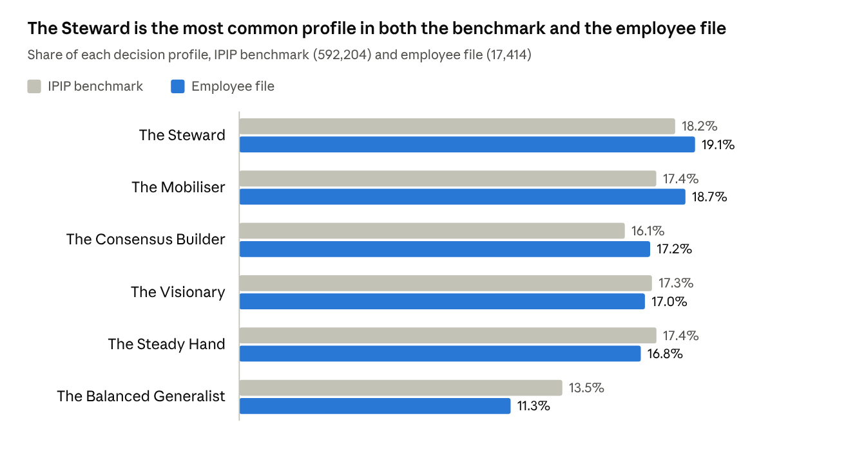
Figure 5. Decision profile shares, benchmark against employee file (KPI 2)
Figure 6 breaks the same profiles down by department. This is the main chart of the View Department Analytics use case on the HR dashboard. No department is above the 35% alert level of KPI 2, and the highest single share is The Steward in Finance and Accounting at 27.5%.
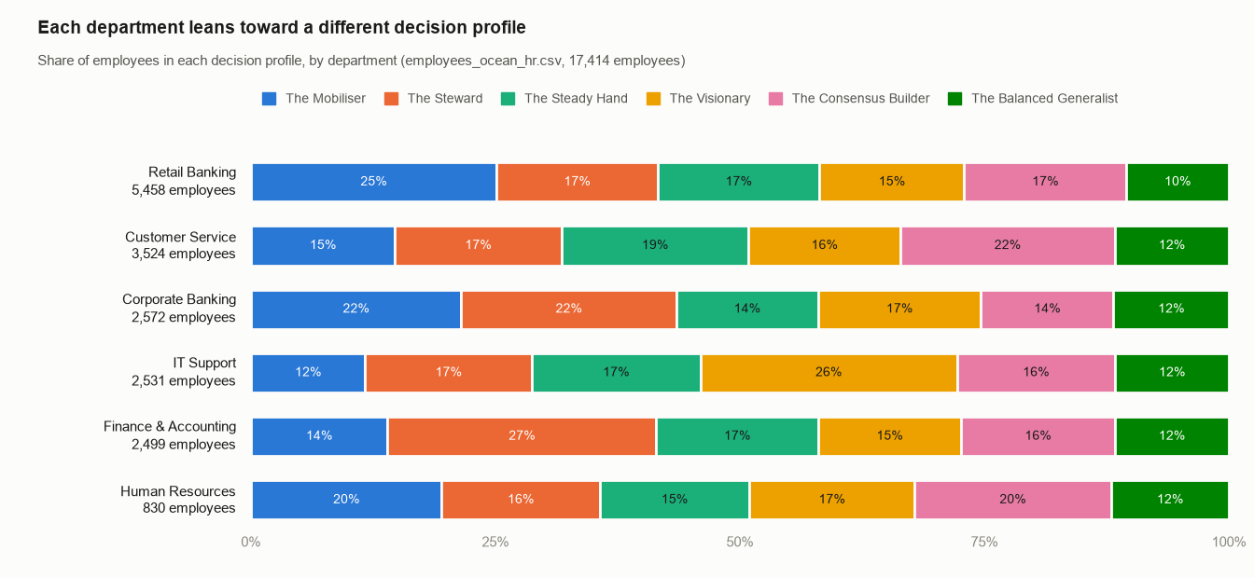
Figure 6. Decision profile by department (KPI 2)

HR data and the 9-Box Grid
Table 24. Department profile (employee file)
Department | Employees | KPI met > 80% | Mean training score | Executive fit | Star | Underperformer
Retail Banking | 5,458 | 27.7% | 50.1 | 15.5% | 7.7% | 19.5%
Customer Service | 3,524 | 44.1% | 60.4 | 14.4% | 11.8% | 10.9%
Corporate Banking | 2,572 | 37.1% | 68.8 | 15.9% | 10.8% | 18.3%
IT Support | 2,531 | 36.8% | 80.5 | 11.4% | 13.1% | 13.9%
Finance and Accounting | 2,499 | 39.9% | 76.8 | 13.9% | 11.2% | 12.2%
Human Resources | 830 | 36.0% | 50.3 | 14.5% | 14.3% | 10.5%

Shares in Table 24 use all employees in each department. Retail Banking has the lowest KPI attainment (27.7%) and the highest Underperformer share (19.5%), so it is the first department for a performance review.
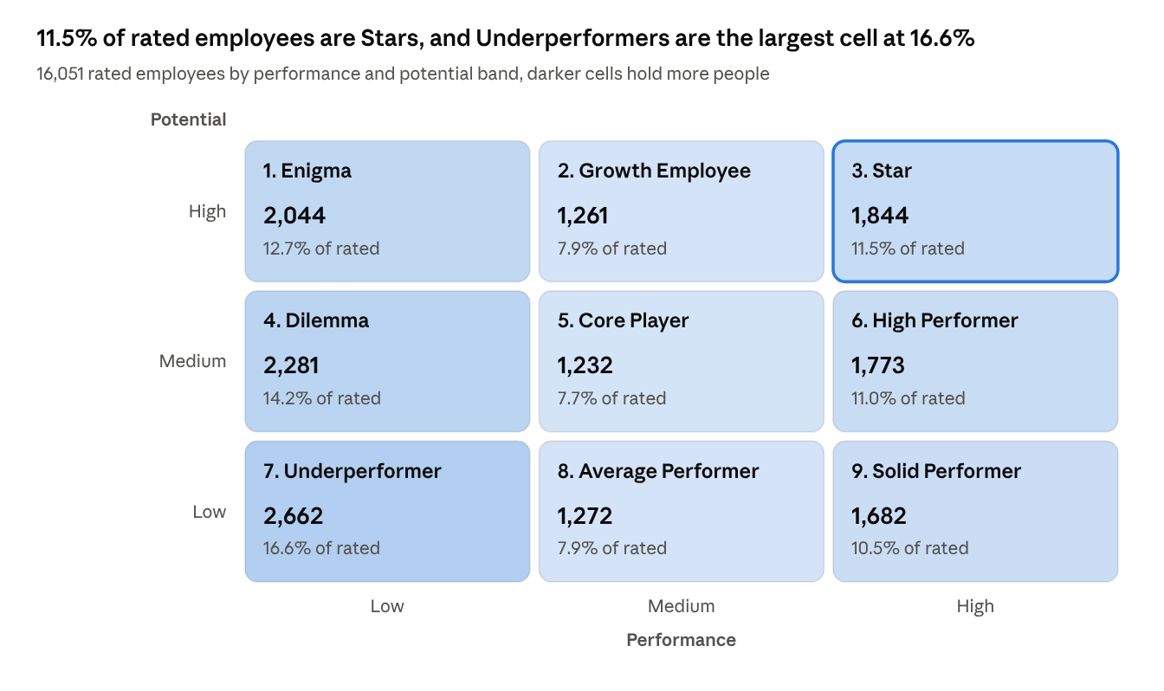
Figure 7. 9-Box Talent Grid of rated employees (KPI 6)
Table 25. Correlation between HR fields (Pearson, 17,414 employees, 16,051 for rating)
 | Rating | KPI | Award | Training | Age | Service | Trainings
Rating | 1.00 | 0.34 | 0.04 | 0.06 | 0.02 | 0.01 | −0.05
KPI | 0.34 | 1.00 | 0.11 | 0.07 | −0.03 | −0.08 | −0.05
Award | 0.04 | 0.11 | 1.00 | 0.08 | 0.00 | −0.04 | 0.00
Training | 0.06 | 0.07 | 0.08 | 1.00 | −0.03 | −0.03 | 0.05
Age | 0.02 | −0.03 | 0.00 | −0.03 | 1.00 | 0.64 | −0.09
Service | 0.01 | −0.08 | −0.04 | −0.03 | 0.64 | 1.00 | −0.06
Trainings | −0.05 | −0.05 | 0.00 | 0.05 | −0.09 | −0.06 | 1.00

Initial patterns
- Rating and the KPI flag agree only moderately (0.34), so using both gives the performance axis more information than either alone.
- Training score has almost no link with rating or KPI (0.06 and 0.07), which suits its use on the separate potential axis. Performance and potential are nearly independent (0.07), so the two 9-Box axes add different information.
- The performance axis is lopsided because many people tie on coarse inputs: the Low band holds 6,987 people and the Medium band 3,765. The potential axis splits into even thirds.
- Underperformers are the largest 9-Box cell (16.6%), and 357 employees are both Stars and executive fit, the first succession shortlist.
- Each department's most common profile matches its assumed tilt (for example The Visionary in IT Support, 26.2%). This confirms the matching worked and is not a finding about employees.

5. Knowledge and Logical Modeling
To be completed in Part 2 (due 19 November 2026). Planned contents:
- Star schema data warehouse with fact tables for assessment results, talent reviews and KPI snapshots, and dimensions for employee, department, trait, profile and date
- Influence diagram from OCEAN traits and HR fields to the seven KPIs
- Structured situation diagram with at least 15 decision situations
- Decision table and decision tree for profile, executive fit and 9-Box actions
- Rule sets for validity, item scoring, trait bands, profiles and 9-Box placement, and a dependency diagram

6. Interface Design and Implementation
To be completed in Part 3 (due 26 November 2026). The Next.js prototype in the repository already implements the assessment, the result radar chart and the HR company view. Part 3 adds:
- A Department Analytics view on the HR dashboard with decision profile by department (as in the chart in section 4.6), executive fit rate by department, and the average OCEAN radar per department
- The 9-Box Talent Grid, what-if analysis and Red, Yellow and Green KPI alerts
- A separate role field for each user, matching the ROLE entity
- The decision support chatbot

References
arashnic. (n.d.). hr-ana [Data set]. Kaggle. https://www.kaggle.com/datasets/arashnic/hr-ana
Goldberg, L. R. (1992). The development of markers for the Big-Five factor structure. Psychological Assessment, 4(1), 26–42.
Group 03. (2026). Meridian OCEAN Executive DSS [Source code, branch feature-implement-OCEAN]. GitHub. https://github.com/Punnaw1t/mbti-banking-app/tree/feature-implement-OCEAN
International Personality Item Pool. (n.d.). Administering IPIP measures, with a 50-item sample questionnaire. https://ipip.ori.org/newBigFive5broadKey.htm
Judge, T. A., Bono, J. E., Ilies, R., & Gerhardt, M. W. (2002). Personality and leadership: A qualitative and quantitative review. Journal of Applied Psychology, 87(4), 765–780.
Sackett, P. R., Zhang, C., Berry, C. M., & Lievens, F. (2022). Revisiting meta-analytic estimates of validity in personnel selection. Journal of Applied Psychology, 107(11), 2040–2068.
sanjanchaudhari. (n.d.). Employee's performance for HR analytics [Data set]. Kaggle. https://www.kaggle.com/datasets/sanjanchaudhari/employees-performance-for-hr-analytics
Tunguz, B. (2020). Big Five personality test [Data set]. Kaggle. https://www.kaggle.com/datasets/tunguz/big-five-personality-test

